

**Joins –** Helps to give results by extracting needed info from more than one table and combines it into a single result. The tables that are going to be combine should have at least one common columns.

**EX:**

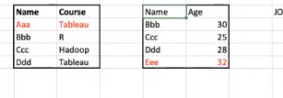

**Join clause –** helps the specify the common columns of two tables, with the help of this only we can join two tables.

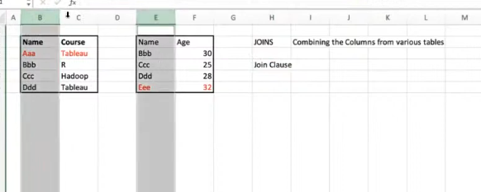

**Types of Join**

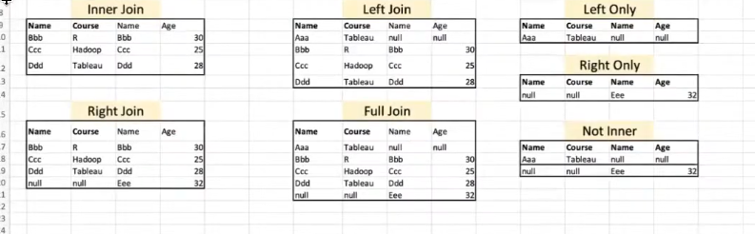

**Inner join –** Matching and combine common data from both table

EX:



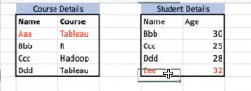

**Result:**

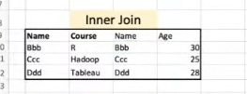

**Left join:**



Un matched right side table values will be ignored in the below example eee is the unmatched values, so it is not appeared in result. But that will included in right join

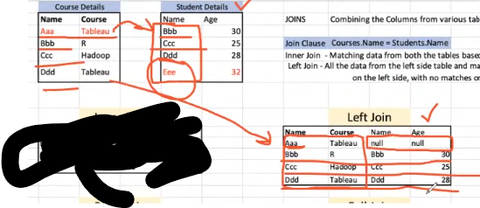

**Right join:**

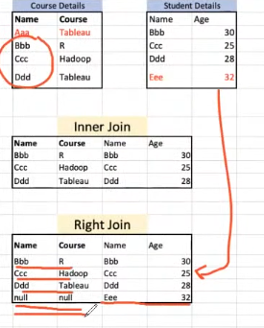

**Full Join –** Unmatched data in both left and right table will also be displayed with null padding

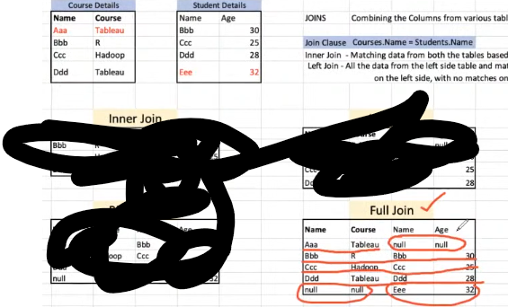

**Left, Right only and Not Inner join**

**Left only -** It gives only the unmatched data from left table compare to right table, takes data present on left table

**Right only –** It gives only the unmatched data from right table compare to left table, takes remaining data present on right table

**Not inner –** It give unmatched data from both sides. Takes remaining data from both table

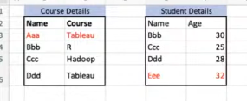 

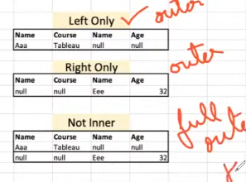

**QUERY EXAMPLE FOR ALL JOINS**

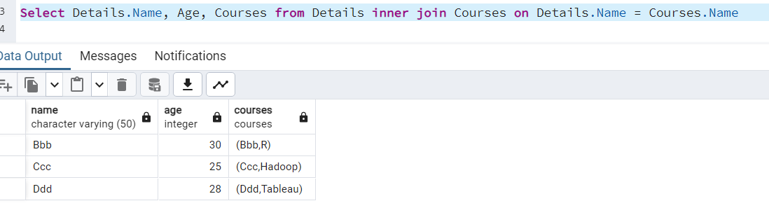

The above thing can also done by where

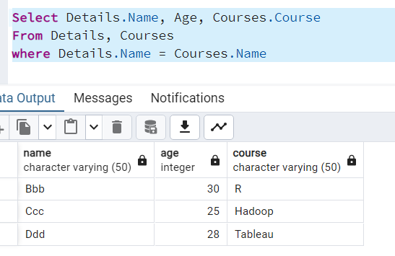

**⚡ Key Difference:**

✅ Both queries return the same result.  
✅ The second query (using INNER JOIN) is **more readable, structured, and maintainable**.  
✅ The first query is an **older style** and can be error-prone in complex queries.

**🔥 Best Practice: Always use INNER JOIN instead of the comma-separated join.**

**Left join and left only query:**

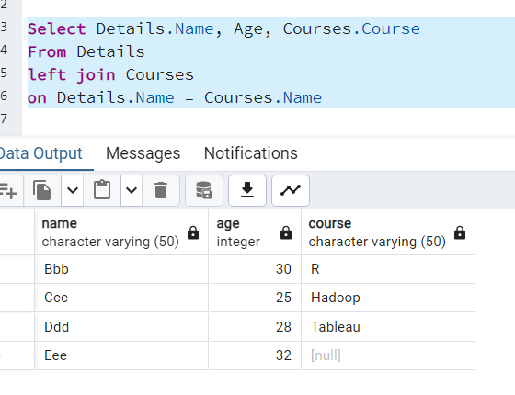

Left outer join is the keyword that eliminate all common elements compare to right side table and gives you the remaining data from left table, but in postgres it is not worked. In below we can see that both left join and left outer join gives you the same result

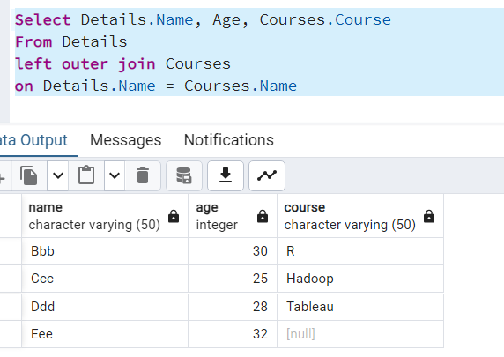

So to do left only operation on postrgres, we can use where condition like below

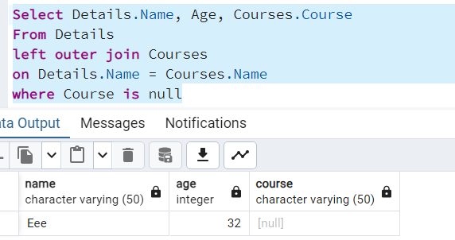

**UNION**

Helps to append the data in a table by taking data from multiple table.

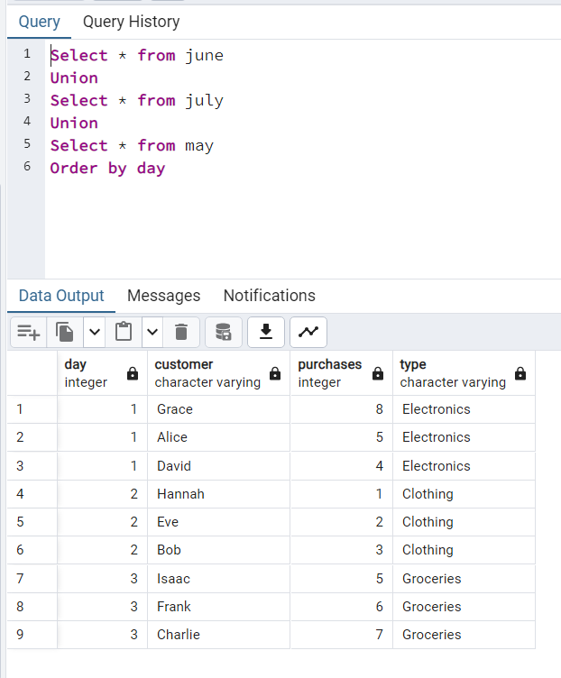

In above we can see that columns are not appended only the rows are extended.

**Create separate table by combining this unions of data**

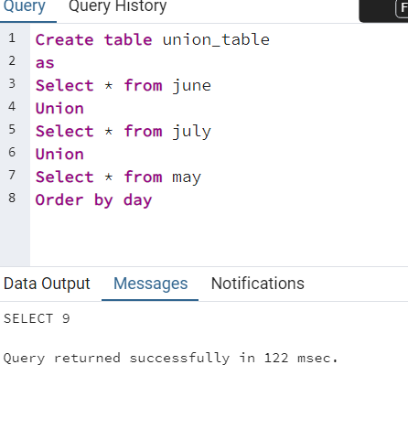

This table needs storage to store this combined data, but we can do this by view also.

**Create view from combined data**

It doesn’t required additional space to store in server the table

